PRERIT

SQL- Subqueries

& Nested SELECTs

Dataset: Online Retail Store

Tables Structure

🟦 customers
CREATE TABLE customers (
customer_id INT PRIMARY KEY,
customer_name VARCHAR(50),
city VARCHAR(50)
);

🟦 categories

CREATE TABLE categories (
category_id INT PRIMARY KEY,
category_name VARCHAR(50)
);

🟦 products

CREATE TABLE products (
product_id INT PRIMARY KEY,
product_name VARCHAR(50),
category_id INT,
price DECIMAL(10,2),
FOREIGN KEY (category_id) REFERENCES categories(category_id)
);

🟦 orders

CREATE TABLE orders (
order_id INT PRIMARY KEY,
customer_id INT,
order_date DATE,
FOREIGN KEY (customer_id) REFERENCES customers(customer_id)
);
🟦 order_items

CREATE TABLE order_items (
order_item_id INT PRIMARY KEY,
order_id INT,
product_id INT,
quantity INT,
FOREIGN KEY (order_id) REFERENCES orders(order_id),
FOREIGN KEY (product_id) REFERENCES products(product_id)
);

2️⃣ Data

Customers

INSERT INTO customers VALUES
(1,'Amit','Delhi'),
(2,'Neha','Mumbai'),
(3,'Rahul','Bangalore'),
(4,'Pooja','Delhi');

categories
INSERT INTO categories VALUES
(1,'Electronics'),
(2,'Clothing'),
(3,'Home');

Products

INSERT INTO products VALUES
(1,'Laptop',1,60000),
(2,'Mobile',1,30000),
(3,'Headphones',1,2000),
(4,'T-Shirt',2,800),
(5,'Jeans',2,2000),
(6,'Mixer',3,4000);
Orders

INSERT INTO orders VALUES
(101,1,'2024-01-10'),
(102,2,'2024-01-12'),
(103,3,'2024-01-15'),
(104,1,'2024-01-20'),
(105,4,'2024-01-22');

Order_items
INSERT INTO order_items VALUES
(1,101,1,1),
(2,101,3,2),
(3,102,2,1),
(4,102,4,3),
(5,103,5,2),
(6,104,1,1),
(7,104,6,1),
(8,105,3,4);

Question

Q1. Find products that are priced higher than the average product price.

Thinking Approach
- First find average price
- Compare each product price with that value
-- write your code
select product_name from products
where price > (select avg(price) from products);
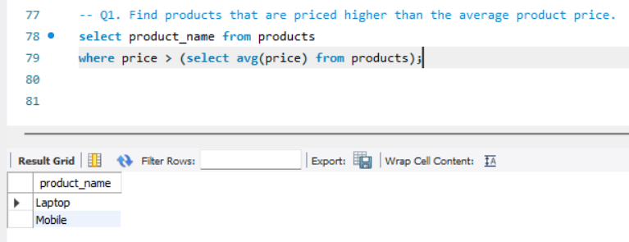

Q2. Find customers who have placed at least one order.

Thinking Approach
- Get list of customer_ids from orders
- Match them with customers table
-- write your code
select
customer_name
from customers
where customer_id in (select customer_id from orders);
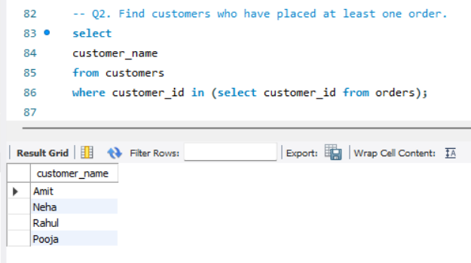

Q3. Find products that are the most expensive within their own category.
-- write your code
select c.category_name, p.product_name, p.category_id, p.price
from products p
join categories c on c.category_id = p.category_id
where price = (select max(price) from products s where s.category_id = p.category_id);

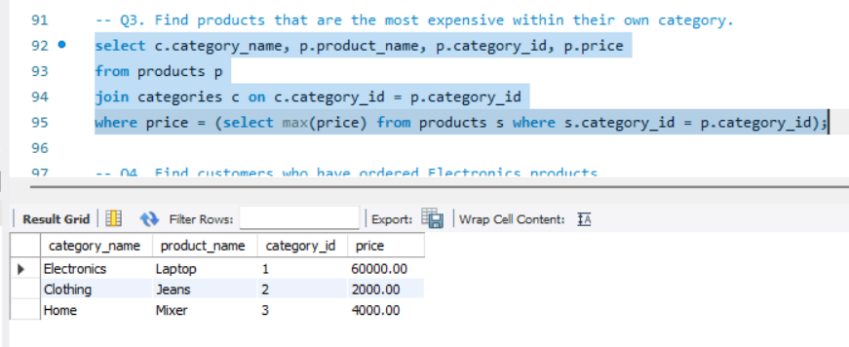

Q4. Find customers who have ordered Electronics products.

Thinking Approach
-- write your code
select customer_name
from customers c
where exists
(select customer_name
from orders o
join order_items oi on o.order_id = oi.order_id
join products p on oi.product_id = p.product_id
where o.customer_id = c.customer_id and p.category_id = 1
);
-- alternate
select customer_name
from customers c
where exists
(select customer_name
from orders o
join order_items oi on o.order_id = oi.order_id
join products p on oi.product_id = p.product_id
join categories ct on ct.category_id = p.category_id
where o.customer_id = c.customer_id and ct.category_name = 'Electronics'
);
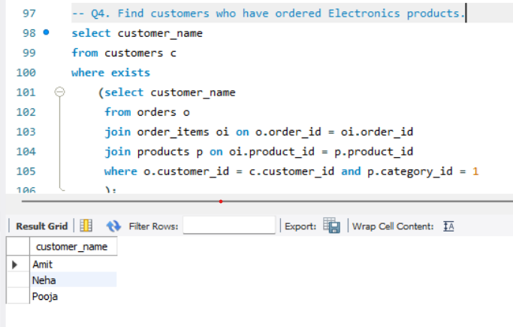

Optional questions

- Products cheaper than average price

select product_name from products
where price < (select avg(price) from products);

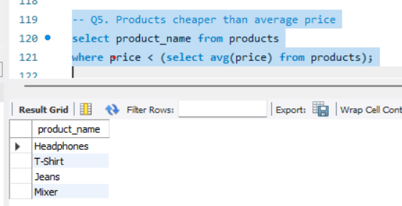

- Customers from cities that have orders

select customer_name, city from customers c
where c.customer_id in (select customer_id from orders o
where c.customer_id = o.customer_id);
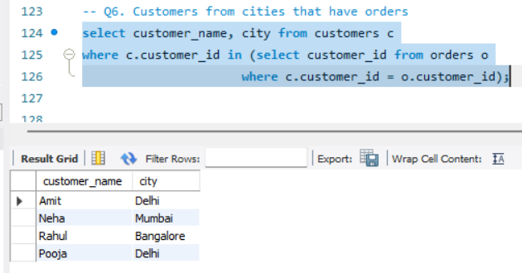

- Cheapest product in each category

select c.category_name, p1.product_name
from products p1
join categories c on p1.category_id = c.category_id
where p1.price = (select min(p2.price) from products p2
where p1.category_id in (p2.category_id));
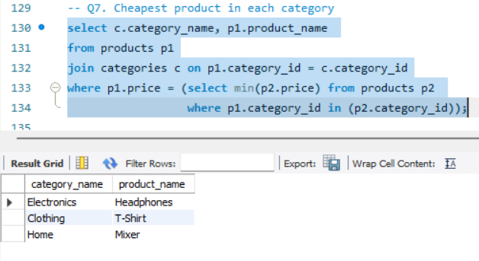

- Customers who ordered Clothing

select distinct c.customer_name
from customers c
join orders o on c.customer_id = o.customer_id
join order_items oi on o.order_id = oi.order_id
join products p on oi.product_id = p.product_id
join categories ct on p.category_id = ct.category_id
where exists (select ct2.category_name from categories ct2 where ct2.category_name = 'Clothing')
